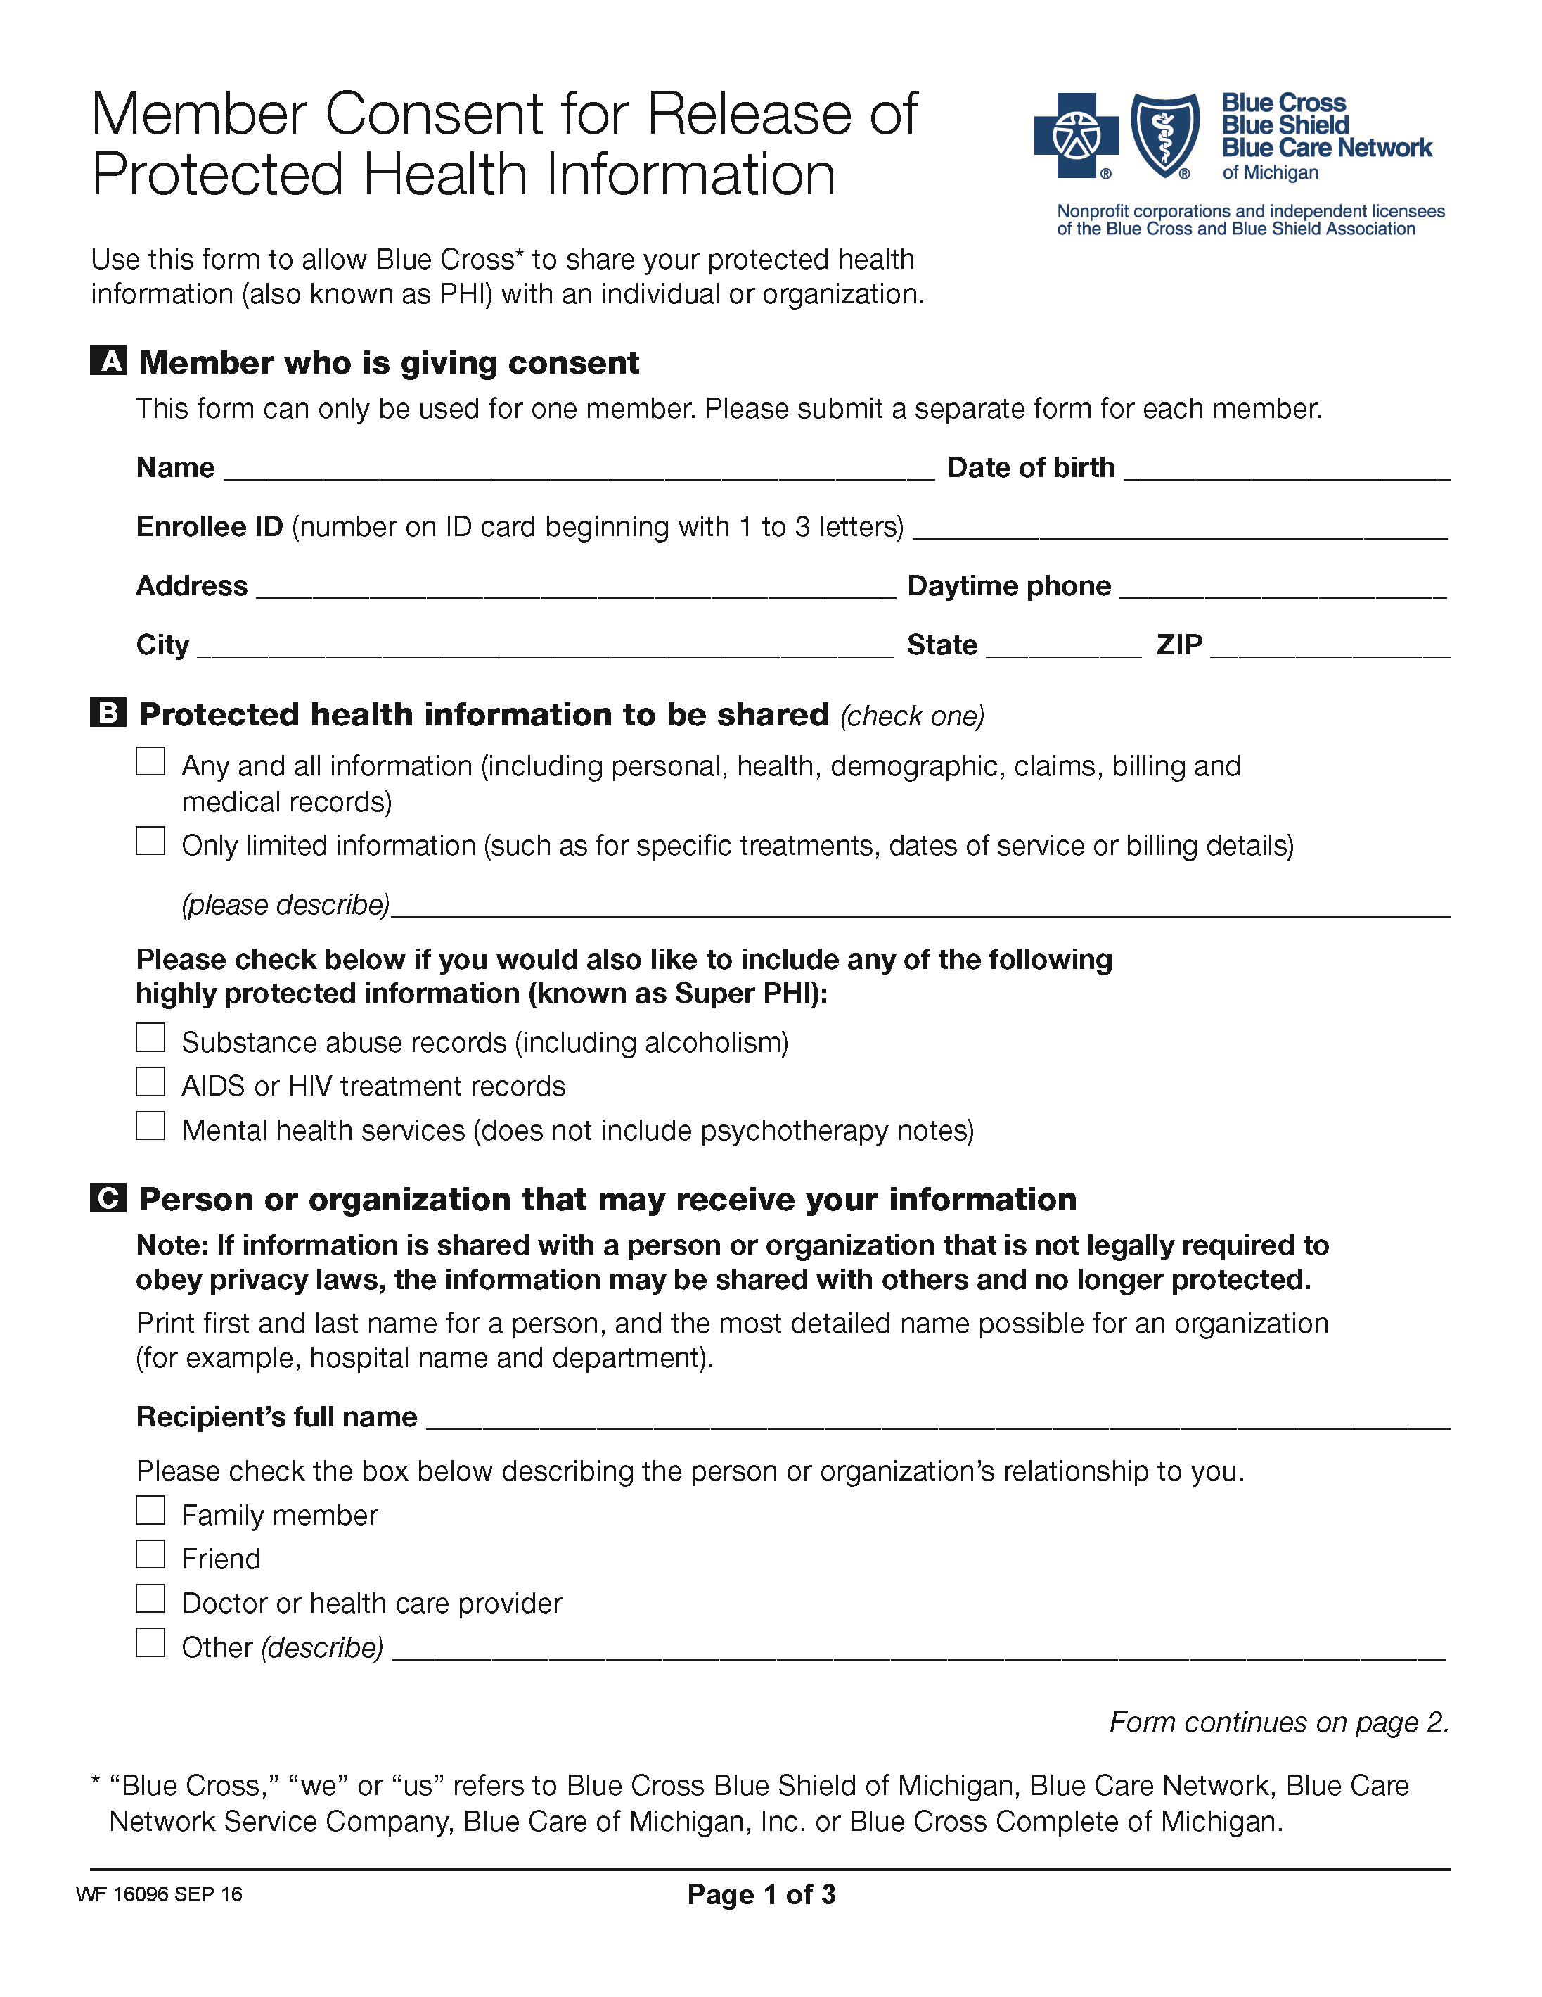
Batman
01/01/1979
FROM 01/01/1979 TO PRESENT: Any and all MEDICAL RECORDS, including but not limited to patient history form(s), reports, etc. pertaining to Batman SSN: xxx-xx-5555, DOB: 01/01/1979.
Axiom Requisition Copy Service - 2869 Jolly Road, Okemos, MI 48864
Litigation Document Requisition
X
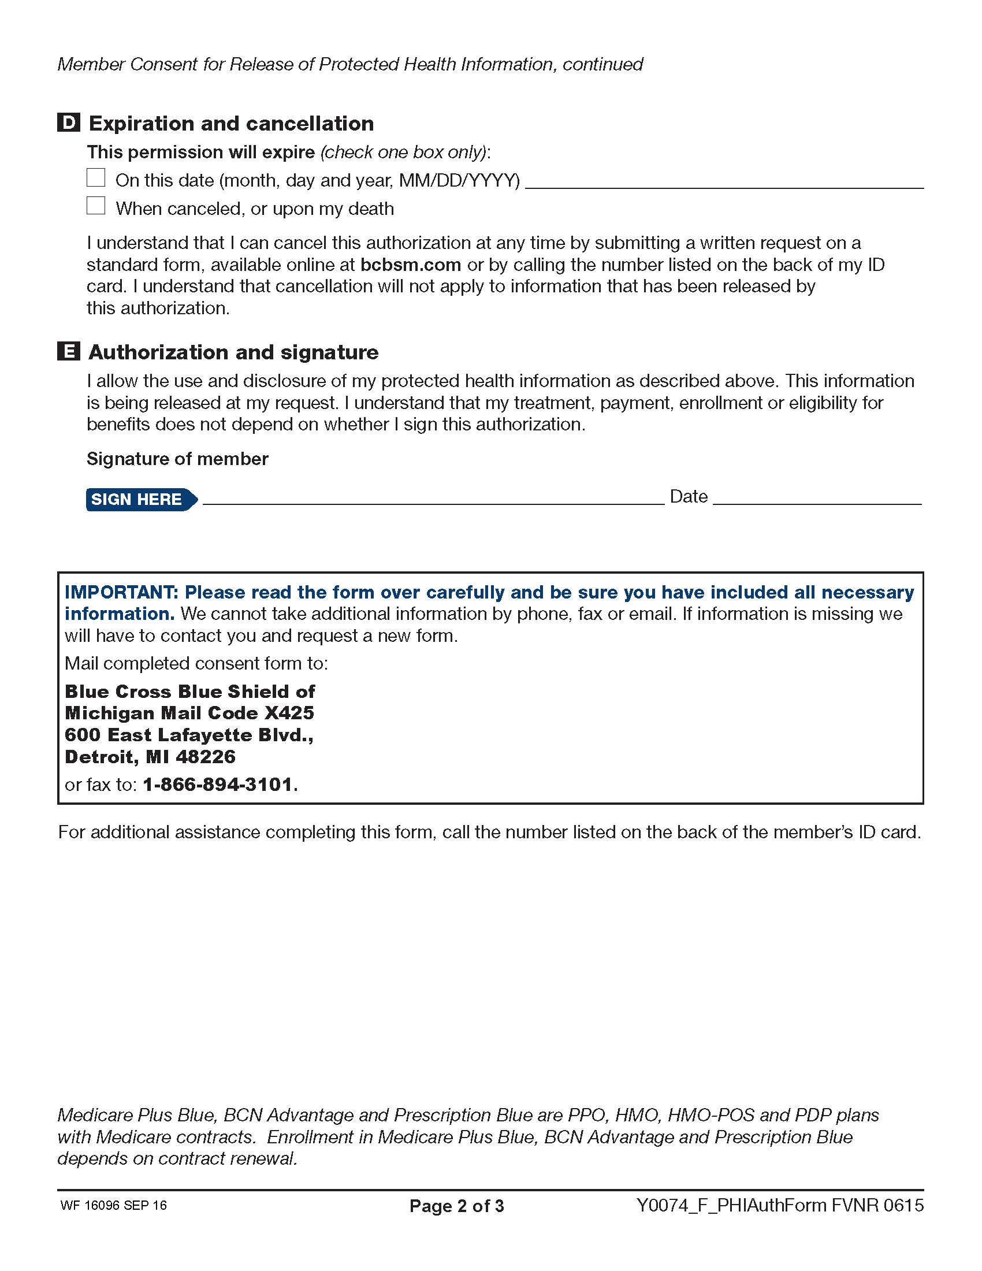
X
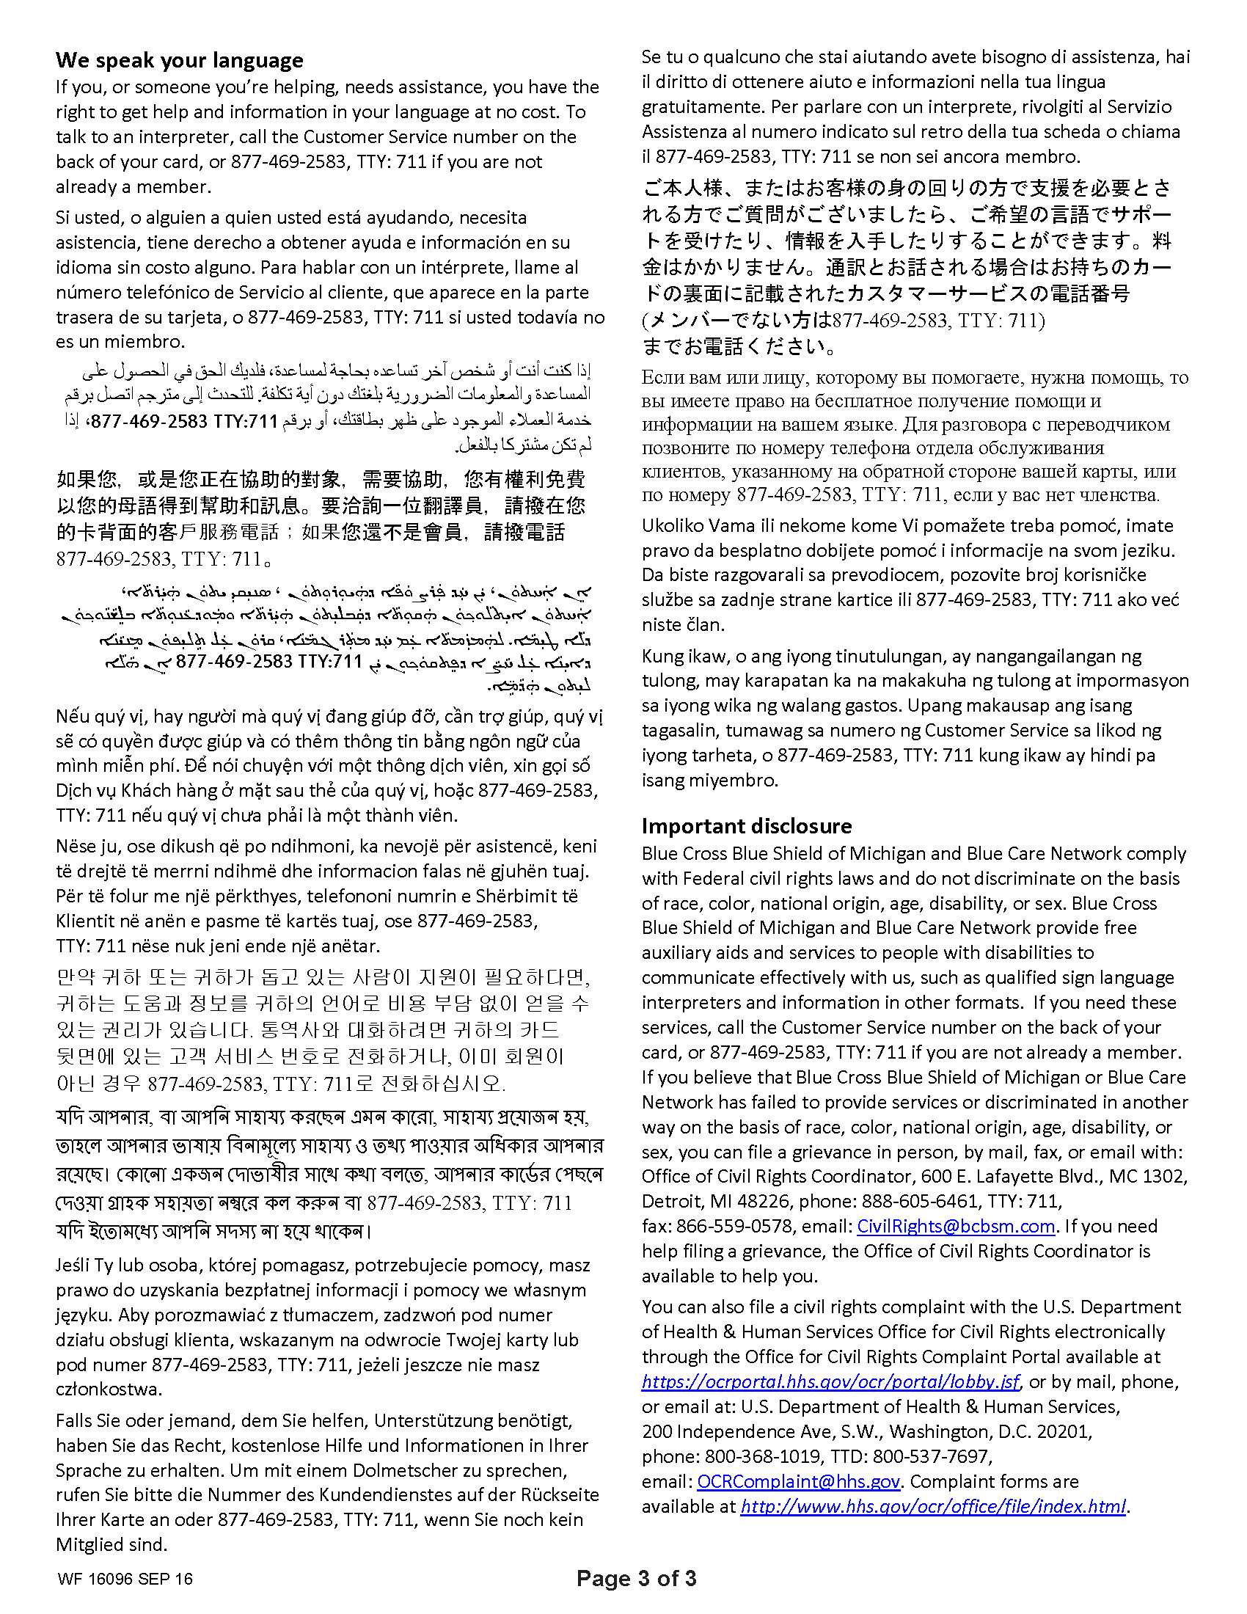
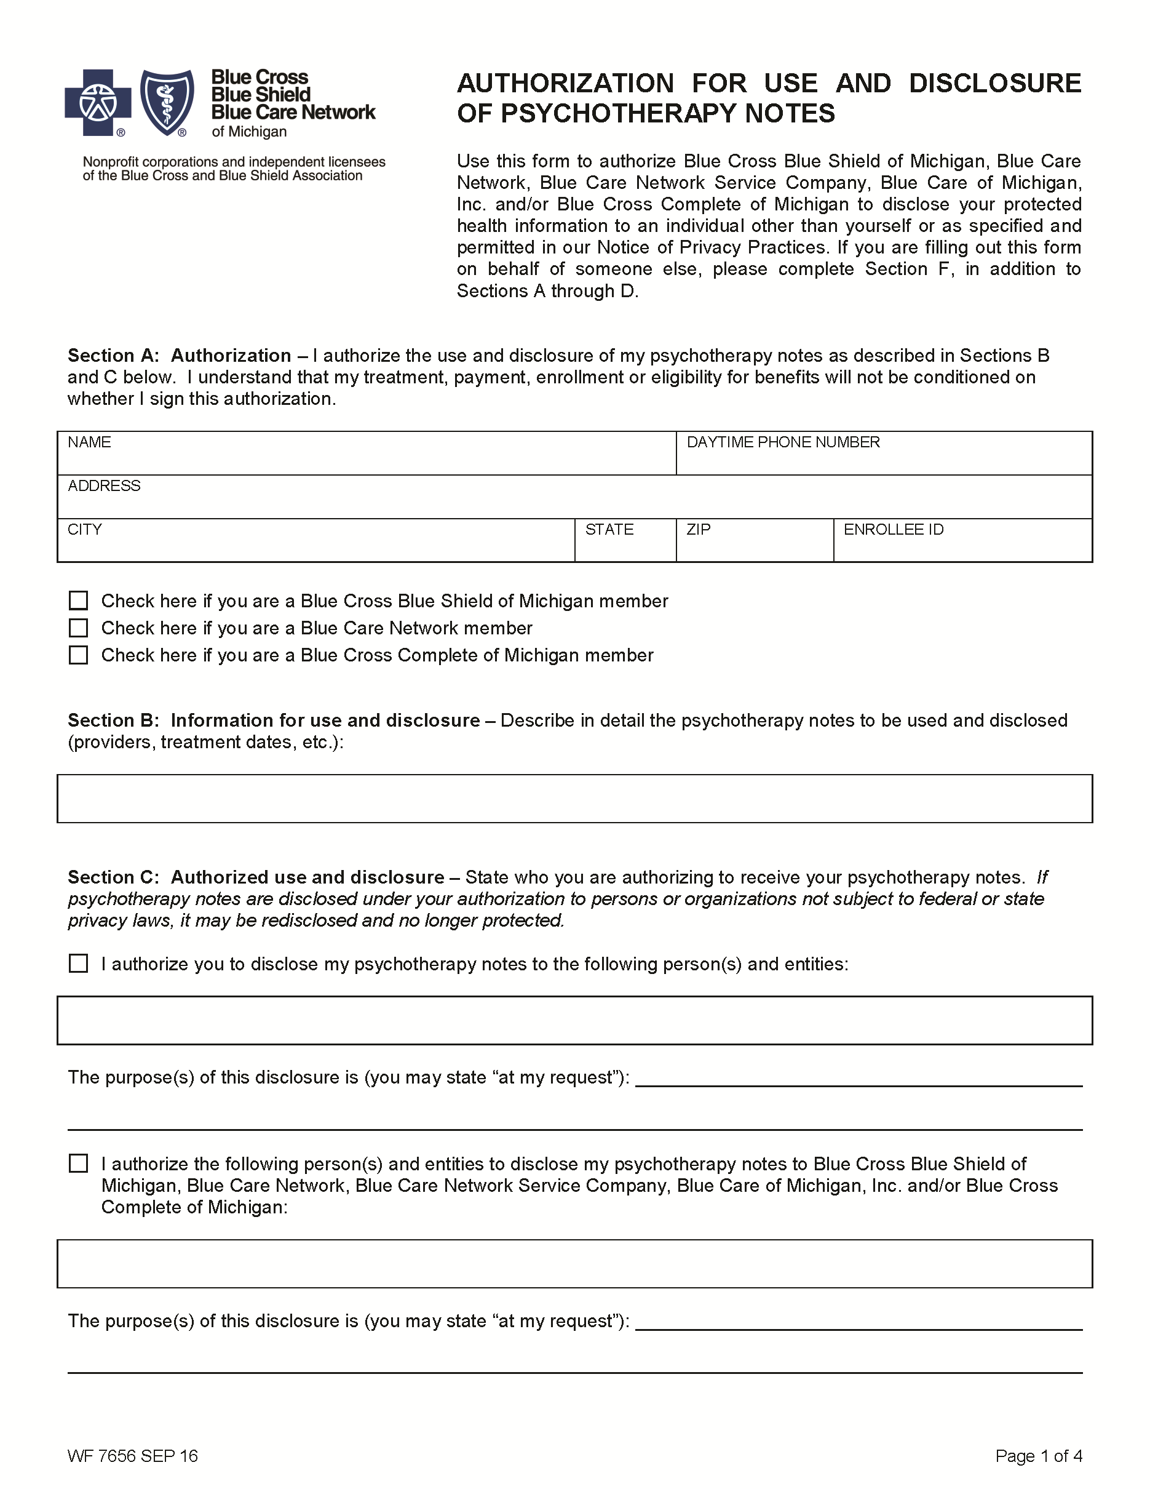
Batman
FROM 01/01/1979 TO PRESENT: Any and all MEDICAL RECORDS, including but not limited to patient history form(s), reports, etc. pertaining to Batman SSN: xxx-xx-5555, DOB: 01/01/1979.
X
Axiom Requisition Copy Service - 2869 Jolly Road, Okemos, MI 48864
Litigation
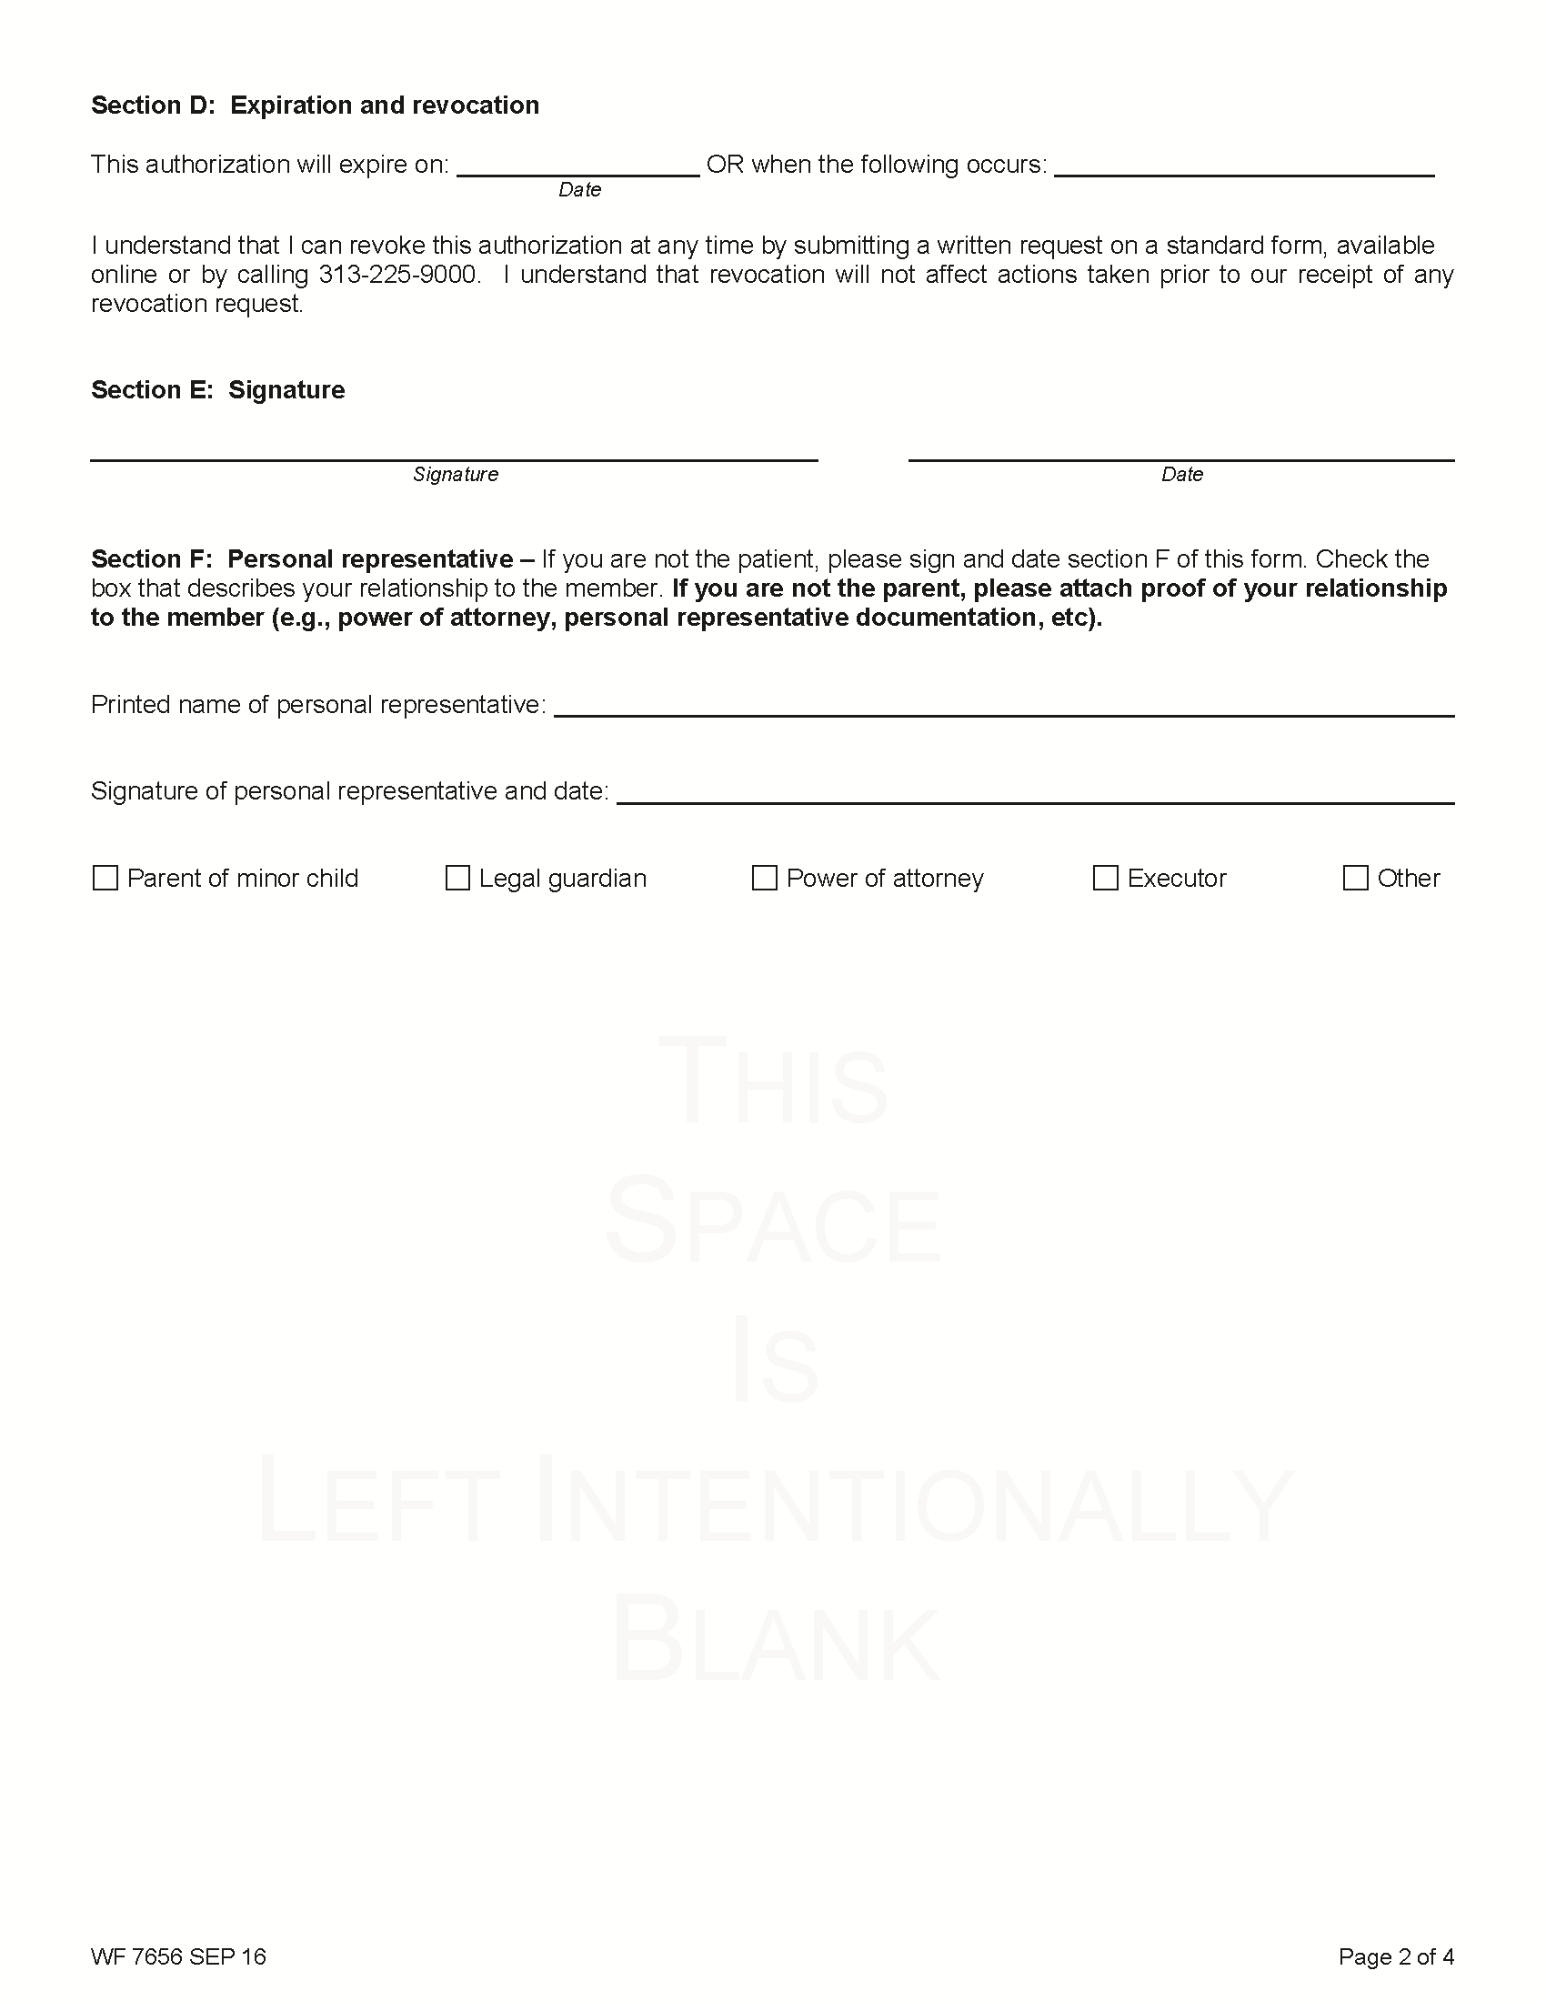
End of Litigation
